IT2120 - Probability and Statistics  
Dulaksha H.K.V.

Exercise

3.

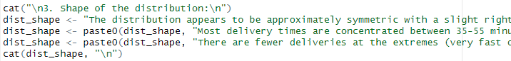

4.

